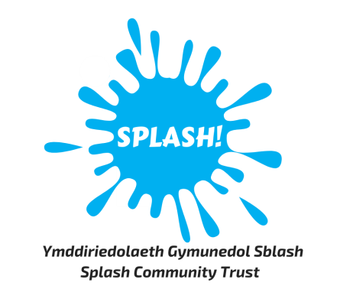

Job Description for Assistant Gym Supervisor

Purpose:
To assist and support the Gym Supervisor in the gym area. The Assistant Gym Supervisor will help with the efficient and effective operation of the gym, delivery of fitness related activities including day to day supervision of the gym, fitness staff and volunteers. You will ensure health and safety requirements are met and that you are customer focused at all times.
To act as Duty Officer, covering for annual leave or sickness when required.

Reports to:
Gym Supervisor

Responsible for:
Staff and volunteers working within the gym and free-lance fitness instructors delivering fitness classes

Salary:
Salary scale £12.40 per hour

Key responsibilities:
Operational
- To prepare individual programmes for customers.
- To deliver fitness classes.
- To advise clients how to use exercise equipment correctly and safely and to gain the best of their time within the gym.
- To promote a welcoming environment to all customers.
- To develop and refine the cleaning and maintenance procedures.
- To maintain accurate and up to date records for customers in accordance with Centre’s policy for data protection and freedom of information act.
- To maintain the facility to ensure the gym is safe and clean ensuring they are checked daily to maintain safety standards.
- To ensure all gym equipment is maintained in a safe working order and action any repairs as required.
- To assist with implementing membership schemes, with ongoing co-ordination and administration responsibilities.
- To complete daily membership checks and contact customers in arrears.
- Assist the Gym Supervisor to introduce membership offers to promote and increase memberships and drive the business forward.
- Interact with members/customers via social media.
People management
- To supervise gym staff and volunteers when necessary to ensure that staff are performing duties in a safe and courteous manner and comply with people management policies
- To assist in producing rotas when needed to ensure adequate qualified staffing levels at all times.
Special conditions
- To act as Duty Manager and cover for annual leave, sickness or for periods as and when required.
- To complete the appropriate training to work as a Duty Officer.
- To be able to work shifts including evenings, weekends and bank holidays.
- To carry out such duties as may be determined by the General Manager.
General responsibilities:
- To maintain the highest standard of professional conduct at all times with customers, colleagues, stakeholders and the general public, both at work and socially.
- To make a contribution to sharing ideas, knowledge and best practice to ensure the long-term success of Splash Community Trust and the Plas Madoc Leisure Centre.
- To adhere to employment policies as detailed in the Employee Handbook.
- To follow all health & safety procedures in order to ensure the safety of you, colleagues, customers and others who may be affected by your behaviour.
- To uphold Splash’s commitment to equality of opportunity to all by following the Equality & Diversity Policy.
- To support Splash in achieving its environmental aims and objectives.

Person Specification
Experience:
- Must be able to demonstrate experience of working within a busy gym environment within the public or private sector
- Must be able to demonstrate a clear understanding of customer needs, ensuring this is central to decision making and service delivery
- Must be able to demonstrate a good understanding of the operation of a gym including health & safety legislation
- Should ideally be able to demonstrate an understanding of how a third sector organisation operates; be sympathetic to the aims of Splash Community Trust; and be sensitive to the political nature of the organisation

Qualifications or Training:
Essential
- REP Level 2 qualified
- Relevant first aid qualification
- Should demonstrate evidence of Continuous Personal Development
Desirable
- REP Level 3 qualified
- Level 3 First Aid at Work
- A pool plant qualification would be an advantage
- A range of fitness class qualifications

Practical Skills:
- Must be able to communicate with a wide range of people effectively at all levels, both orally and in writing, with an ability to motivate
- Must have excellent Information Technology skills
- Must have excellent product knowledge and experience of a wide range of gym equipment
- Must have the ability to empathise and work with customers of all age groups and levels of ability
Personal Qualities & Attributes:
- Must be able to work unsupervised and to agreed outcomes
- Must have a flexible and adaptive attitude to change and do everything to make new approaches and methods work
- Must be able to work in a busy leisure environment
- Must be able to work as part of a team
- Must have an open, honest, approachable and pleasant, friendly personality
- Must have a high understanding of the commitment to a healthy lifestyle
- Must have a high level of personal integrity and motivation
- Must be confident and professional
- Must ensure personal appearance is of the highest standard of tidiness and hygiene
- Must accept the importance of maintaining and improving standards and strive to exceed expectations at all times

This post will require an enhanced disclosure under the Protection of Children Act 1999.

