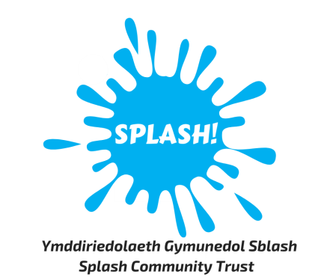

Plas Madoc Leisure Centre is looking to recruit an Assistant Gym Supervisor
1 x full time post (35 hours per week)
All applicants must hold a level 2 Gym Instructor Qualification
Hourly rate: £12.40
Splash Community Trust is a “not for profit” community charity. We offer a range of leisure services, a community café, community support hub services and provide vital links for the immediate and surrounding communities. We are a successful social enterprise with aspirations to continue to develop and are looking for people to join us on our journey.
We are looking for an enthusiastic, motivated person who can work as part of a team and provide excellent customer service. We are looking to recruit an experienced person who can become a valuable member of our fitness team. Your duties will include supporting the Gym Supervisor in ensuring the efficient and effective operation of the gym, inductions, writing individual programmes and ensuring professionalism is maintained at all times.
You will be required to follow a 3 week rota pattern which includes evenings, weekends and bank holidays.
This shift pattern may change in line with the business’ needs.
Please read the full Job Description for more details of the requirements for this role.
An application form is available from our website www.plas-madoc.com
Please forward completed application forms to denise.chadwick@plas-madoc.com
Closing date for applications is Wednesday 17th April 2024

